**Helm installed in the Kubernetes cluster**

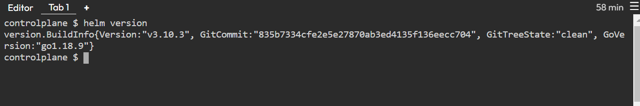

**Problem 1:**

**Version of mysql image set in values.yaml**

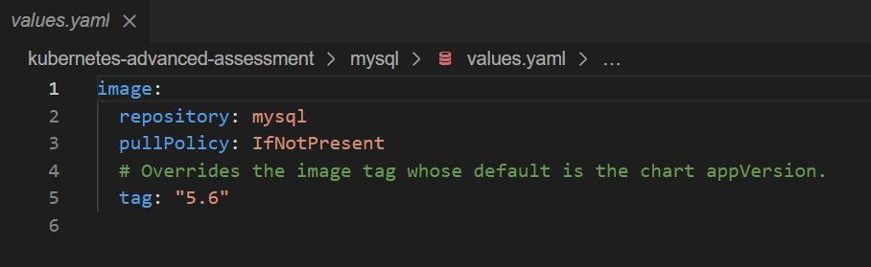

**Deployed the first version of mysql**

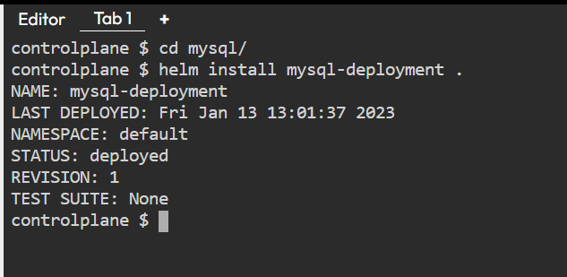

**Updated the image version**

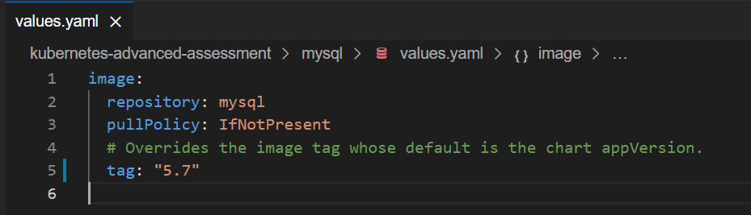

**Upgraded helm deployment**

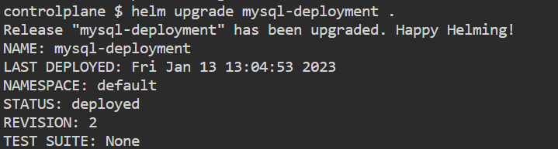

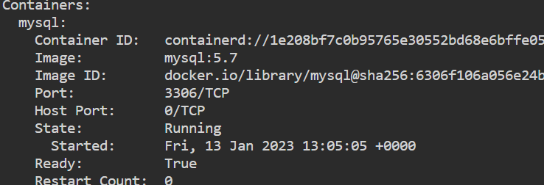

**Problem 2:**

**Values.yaml**

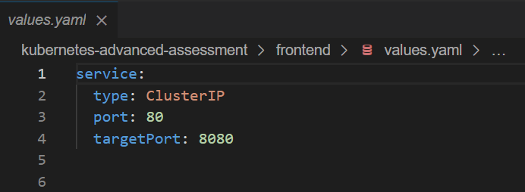

**Fronted deployment created**

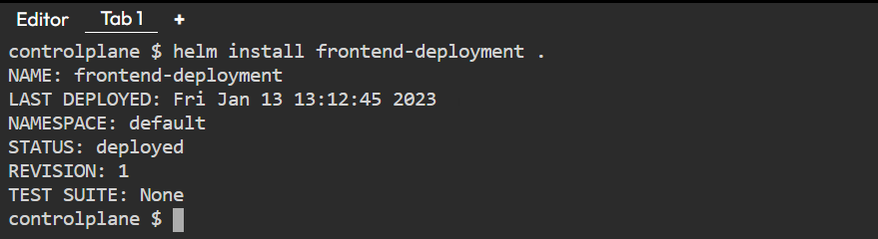

**Values.yaml updated**

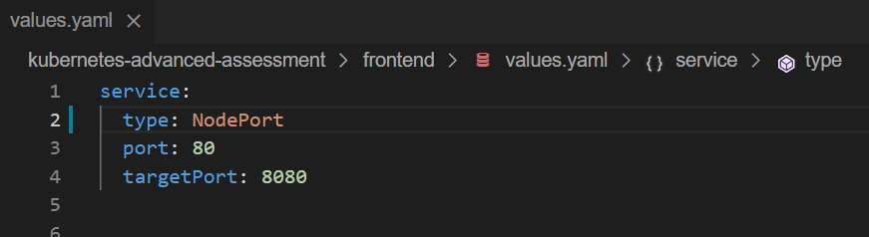

**Deployment updated**

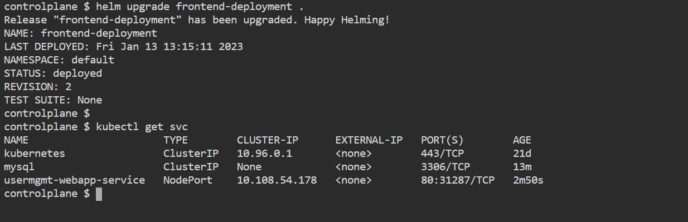

**Values.yaml**

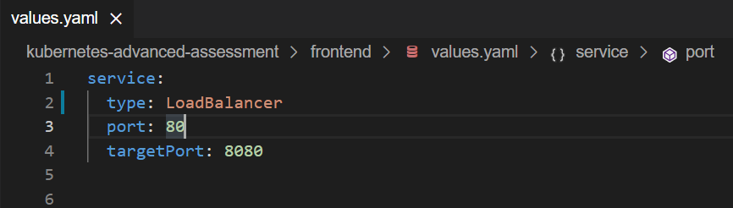

**Deployment updated**

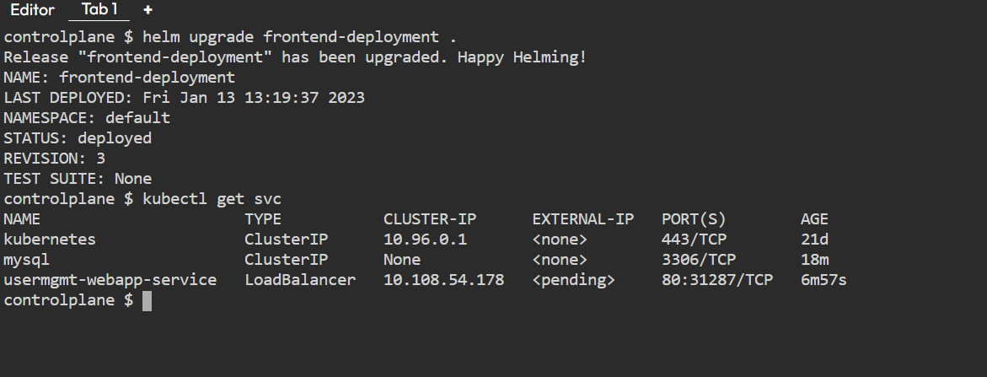

**Application accessible on browser**

